Experiment Details

|  |  |
| --- | --- |
| Department Name | Electrical Dept |
| Class | S.Y.B TECH |
| Semester | III |
| Subject Name | Measurement and Instrumentation |
| Experiment No. | 1 |
| Experiment Name | Wheatstone bridge |

Version History

|  |  |  |  |  |
| --- | --- | --- | --- | --- |
| Sr. No. | Version Number | Created By | Approved By | Date |
| 1 | v1.0 | Priya Yadav | Mrs. Sushmita Sharma | 12/10/2020 |
|  |  |  |  |  |

AIM:

Measurement of unknown resistance using Wheatstone’s bridge.

THEORY:

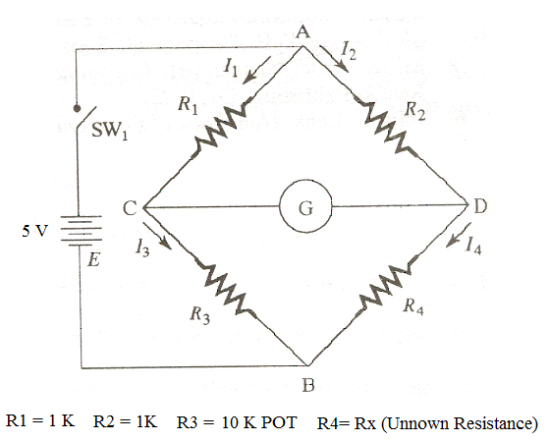

A bridge circuit in its simplest form consists of network of four resistance arms forming a closed circuit, with a dc source of current applied to two opposite junctions and a current detector connected to the other two junctions. Wheatstone’sbridge is used for accurate measurement of resistance . The circuit diagram of a typical Wheatstone’sbridge is given in fig.1.

When SW1 is closed, current flows and divides into the two arms at point A, i.e. *I1* and *I2.* The bridge is balanced when there is no current through the galvanometer, or when the potential difference at points *C* and *D* is equal, i.e. the potential across the galvanometer is zero. To obtain the bridge balance equation, we have from the fig. 1.1,

**I1 R1 = I2 R2 -------------- (1.1)**

For the galvanometer current to be zero, the following conditions should be satisfied.

**I1 = I3 = E/( R1 + R3) and I2 = I4 = E/( R2 + R4)**

Substituting in Eq. (1.1)

**(E*R1)/(R1+R3) = (E*R2)/(R2+R4)**

**R4 (unknown Resistance)=Rx = (R2*R3) / R1**

This is the equation for bridge to be balanced

PRE-TEST:

1. What is Wheatstone bridge
2. A.C bridge
3. **D.C bridge**
4. High voltage bridge
5. Power dissipation bridge
6. How many resistances are used in the circuit of wheatstone bridge
7. 2
8. 3
9. **4**
10. 5
11. When is bridge balanced
12. When current passes through the galvanometer
13. **When no current passes through the galvanometer**
14. What should be done in order to obtain balanced bridge equation
15. **I1R1=I2R2**
16. I2R1=I1R2

PROCEDURE:

1. Connect the circuit as shown in figure.
2. Apply the supply +5 v source to the circuit.
3. Set the R1, R2 at a convenient value and obtain the balance by varying R3 from the resistance box.
4. Run simulation. Observe the milivoltmeter pointer.
5. If "NULL" is achieved, click "Calculate" (on mode). At this condition, simulate again. Observe calculated values of unknown resistance of R4.
6. If better "NULL" is desired, click calculate (off mode).
7. Repeat the procedure with different value R3.

|  |  |  |
| --- | --- | --- |
| Sr. No | Unknown Resistance (Measured Value) | Unknown Resistance (Actual Value) |
| 1 |  |  |
| 2. |  |  |
| 3. |  |  |
| 4. |  |  |
| 5 |  |  |

POST TEST

1)When the condition R1/R2=R3/R4 is satisfied the current in the galvanometer of the wheatstone bridge is a. 1

b. **0**

c.min

d.max

2) Simplest applications of wheatstone bridge is a.voltage measurement

b. current measurement

c**. light measurement**

d. power measurement

3) Wheatstone is used to measure resistance in the range of

a. **1ohm to few megaohms**

b.10kohm to a few megaohms

c.100Mohms to a few gegaohms

d.100ohms to a few teraohms

4)The opposite ends of a wheatstone bridge consist of

a. voltage and current source

b.**emf and null detector**

c. resistance and capacitance

d.inductance and impedance

REFERENCES:

A.K. Sawhney, Electrical and Electronic Measurements and Instrumentation, Reprinit 2010 : Dhanpat Rai & Co.

WEBSITE:

<https://portal.coepvlab.ac.in/vlab/auth/home?dept=3&lab=11>

<http://vlabs.iitkgp.ernet.in/asnm/>